report-1

September 30, 2019

**0.1** **Here is the summary of what are tried, what worked for me and what not**

* My baseline score is 86.23. I believed it was due to over-fitting. And as the features are unknown, so it was difficult to make an interpretation for feature engineering. So i followed several approach to do that

1. Handle NULL value, with two ways
   * use tree-based method
   * created an indicator variable to represent NULL and fill it with some number in original feature
   * used MICE(didn’t help)
2. Target encoding(didn’t helped)(due to target leakage, tried to handle it carefully, but failed)
3. Removed highly correlated feature
4. Used p-test to remove irrelavant feature(It again can create some problem, as OLS is linear model)
   * I carefully selected p-value, one for linear model
   * other for further feature processing
5. SVD/PCA/NMF feature on original and selected dataset.
   * use NMF, we get 2 advantage
     1. it create new feature(as we need absolute value)
     2. feature space tramnformation
6. feature interaction, (i created a list of 20000 complex feature)
   * Select a subset of 300-400 feature, prepare dataset
   * build model to evaluate those feature
     1. If score < baseline: remove them
     2. Else: calculate oof prediction
7. created an ensemble
   * catboost/xgboost/logistic-regression/passive-aggressive/ridge

\

**0.2** **I faced problem in final submission, so i just su**

**0.3** **Highly suspicious feature**

* These columns have very weird distribution and are highly cardinal
* Another also have high correlation
* ['Col190','Col191','Col192','Col204','Col230','Col242','Col252','Col253',

'Col912','Col347','Col384','Col387','Col388','Col389','Col401','Col427',

'Col439','Col449','Col450','Col544','Col579','Col580','Col581','Col582',

'Col583','Col584','Col585','Col586','Col587','Col597','Col603','Col623',

'Col635','Col702','Col711','Col724','Col742','Col791','Col799','Col800',

'Col813','Col831']

**0.4 I don’t understand what my model is learning, following columns are garbage(1 cat is majority 99.9%, rest are single tuple)**

- If we remove these columns `f1-score` for minority class decrease, but weighted average remain

In [9]: del_cols = ['Col635','Col427','Col242','Col230','Col439','Col623','Col597','Col401','Col train.drop(del_cols, axis=1, inplace=True)

test.drop(del_cols, axis=1, inplace=True)

**0.5 I tried to bins/groups sone rare occuring label/category for few columns, which have bincount as described below, but that doesn’t helped much**

|  |  |
| --- | --- |
| In [ ]: # 0.000000 | 13890 |
| # 1.000000 | 1302 |
| # 0.666667 | 544 |
| # 0.333333 | 481 |
| # 1.333333 | 85 |
| # 2.000000 | 53 |
| # 1.666667 | 38 |
| # 3.000000 | 11 |
| # 2.333333 | 9 |
| # 3.333333 | 7 |
| # 4.666667 | 2 |
| # 2.666667 | 2 |
| # 5.000000 | 1 |
| # 6.333333 | 1 |
| # 4.000000 | 1 |

**0.6 My observation on** Logistic-Regression **with** balanced **classes-weights**

* choose alpha = [0.1, 1] for better f1-score for minority class
* logistic-regression works good on interaction based feature

**0.7 observation about** PassiveAggressiveClassifier

1. with squared_hinge:

\

* + with balanced class-weight alpha of [0.0001, 0.001, 0.01], 2nd is best, it will help in ensembling as recall is high of one class as compared to others
  + without balanced, use alpha = [0.001]

1. with hinge:
   * with balanced, alpha = [1, 9, 10]
   * without balanced, use alpha = [0.001]

**0.8** **Weirdness in data(in approximately 1200 rows)**

• these rows were effecting model boundary, so i dropped these columns

* **By removing these weird observation, we get following count-plot**

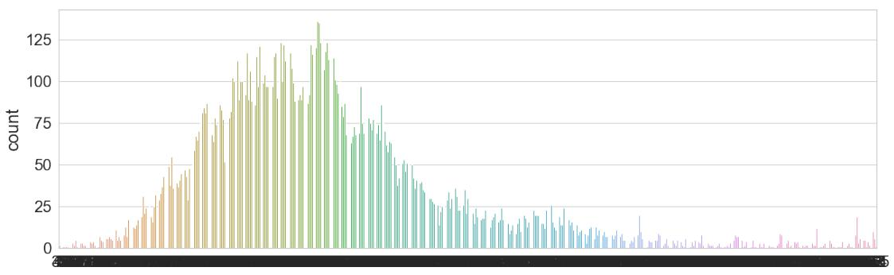

In [56]: train1.drop_duplicates().shape, train.shape

Out[56]: ((16405, 3171), (17521, 2391))

* **Countplot with weird observation**

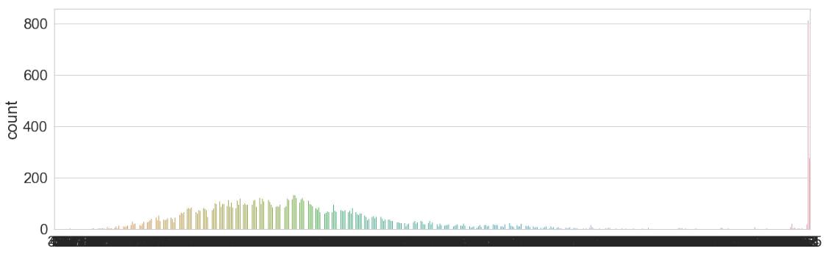

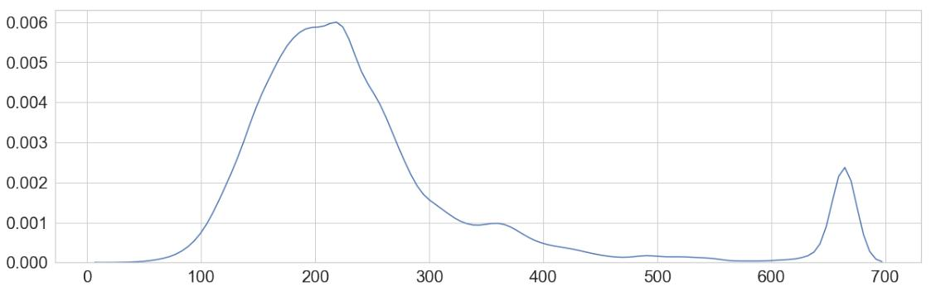

* **distribution visualization of good columns, which influence the de-cision**
  + My observation:

**–** Most of them have good(normal/skewed) distribution

**–** With log transformation, these are very good for linear/non-linear model

**–** If we compared these with feature of less importance, these have good statistical prop-erties

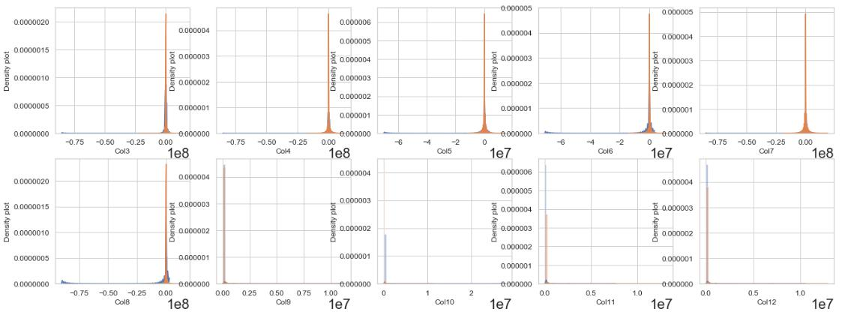

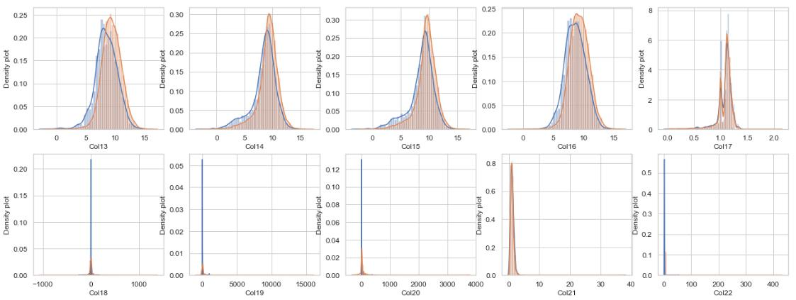

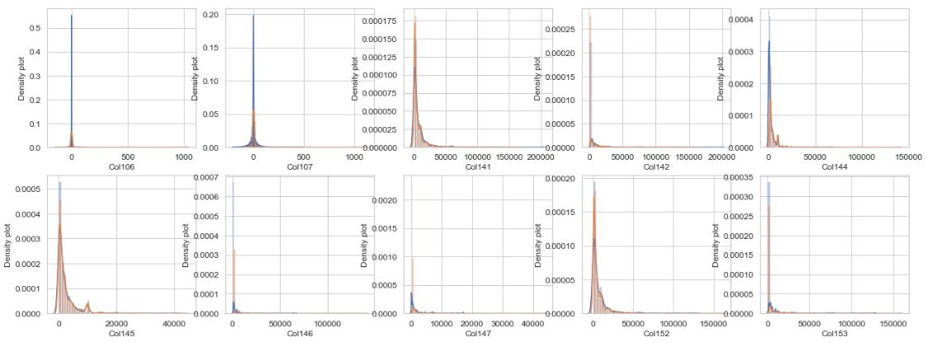

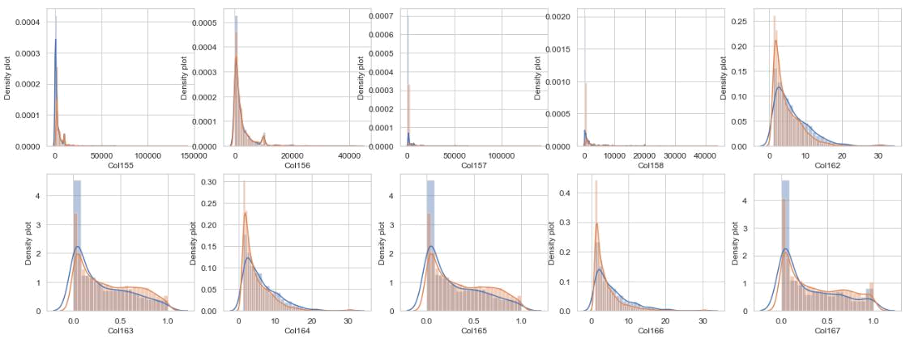

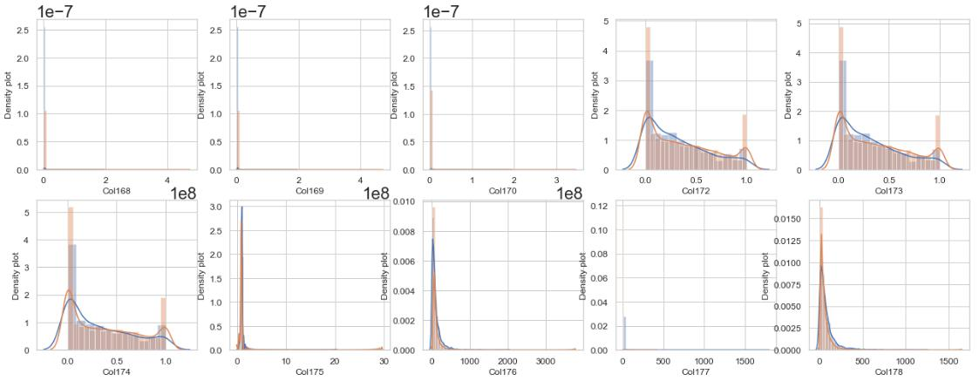

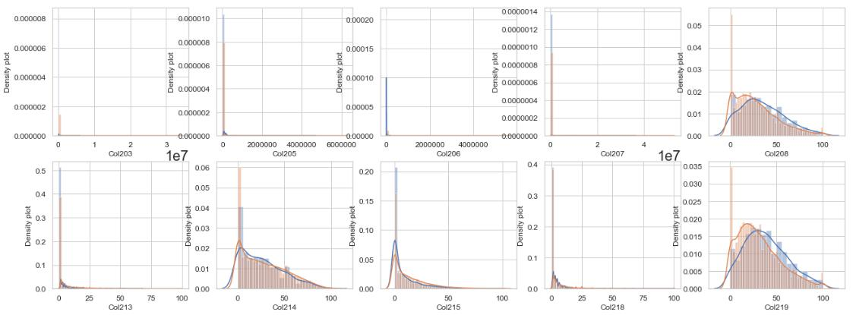

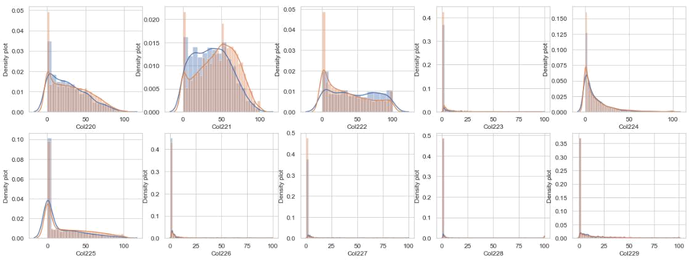

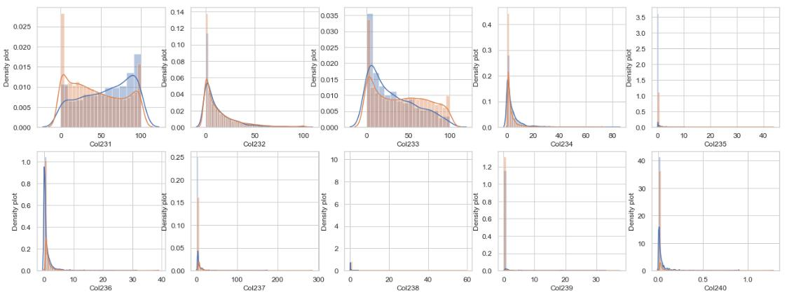

In

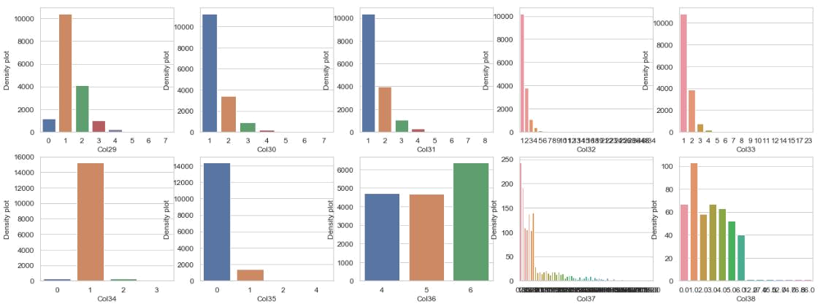

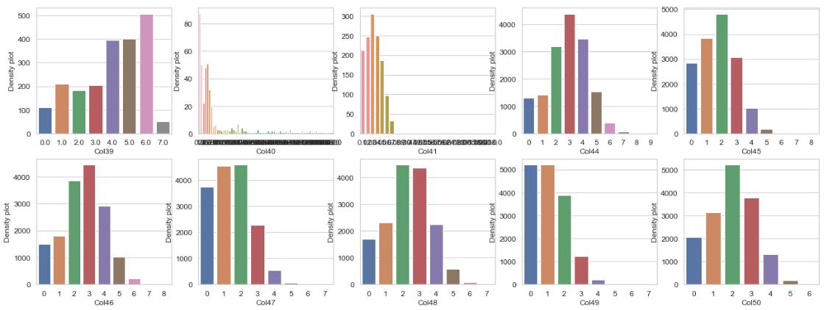

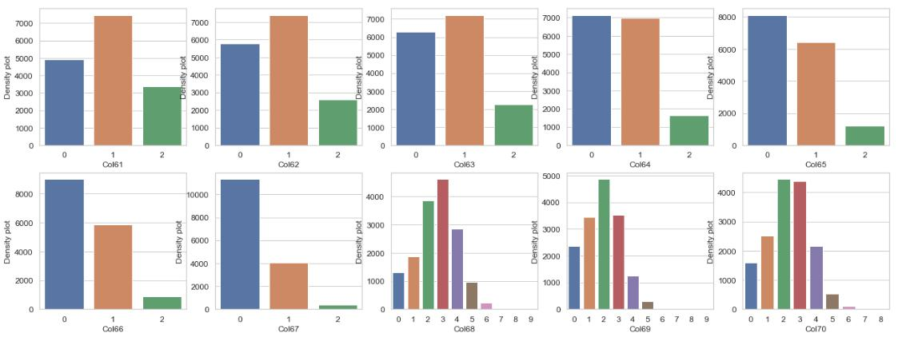

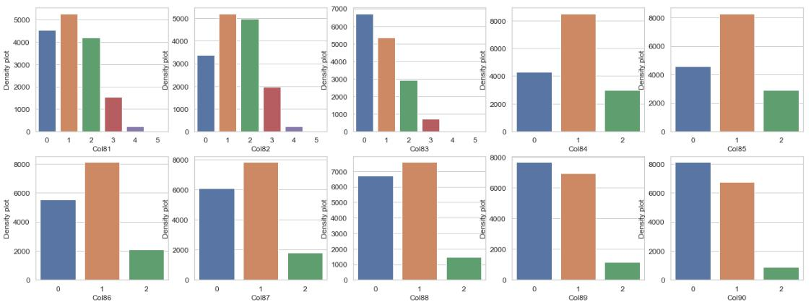

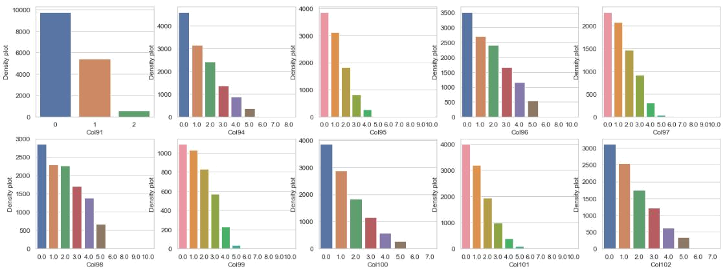

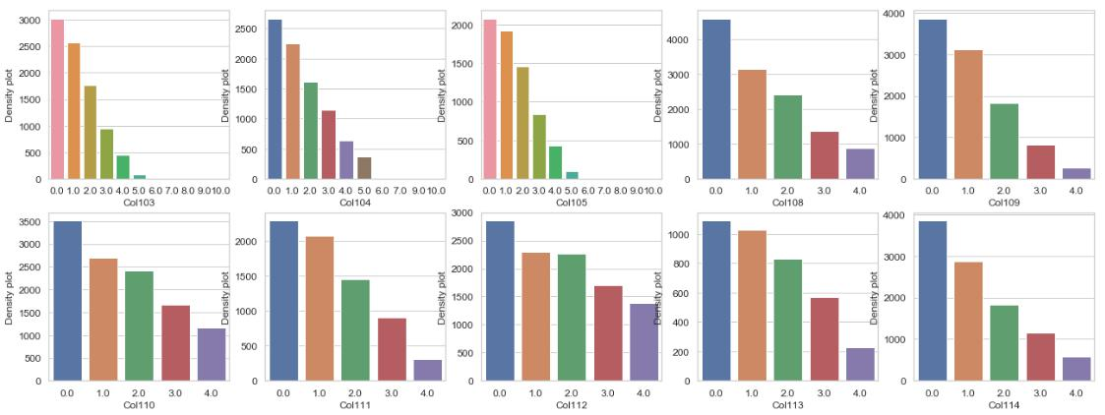

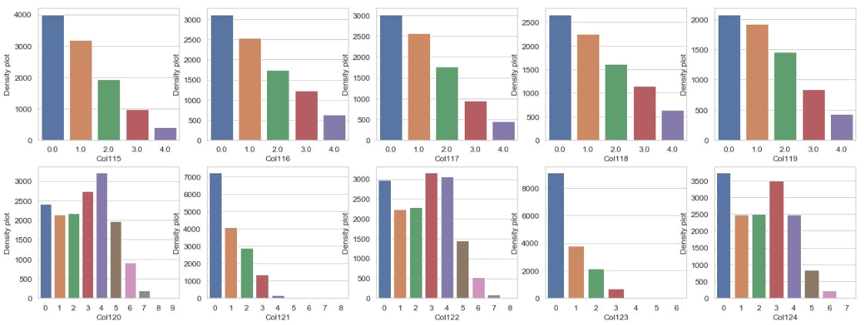

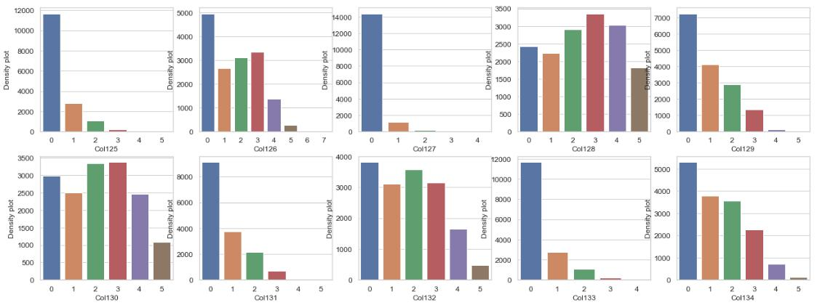

**3.1** **Some of those have null importance to tree-based and deep learning models**

* My observation:

**–** these feature looks funnier

**–** their high cardinality has reduce the importance.

**–** a few of them such as[col143, col148, col186-195,...]has majority class amountas >95%.

**– one intersting point** that a few of them have only values/label for class1and null forclass 0. I removed them

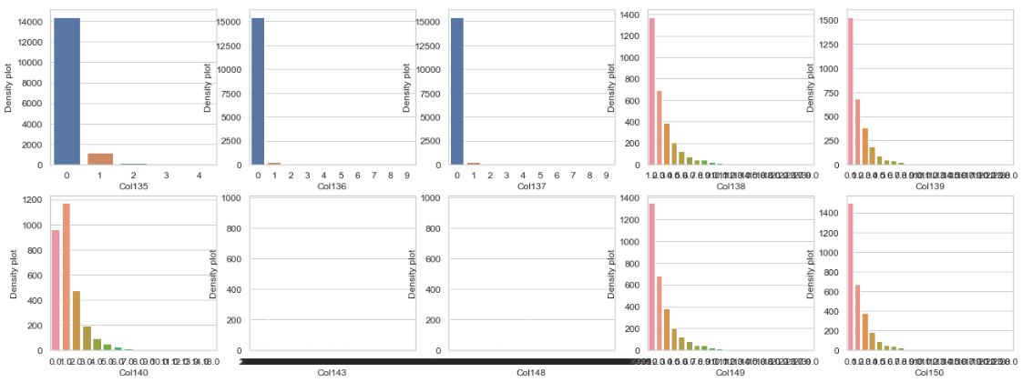

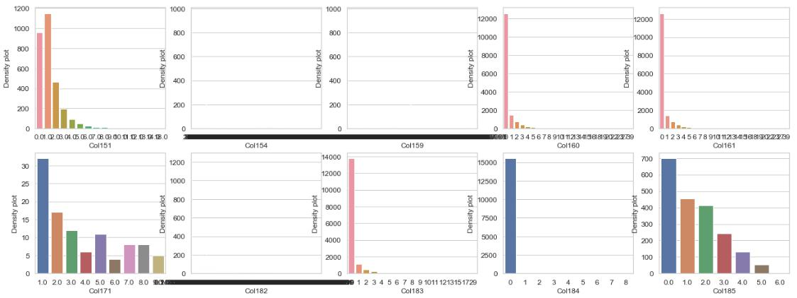

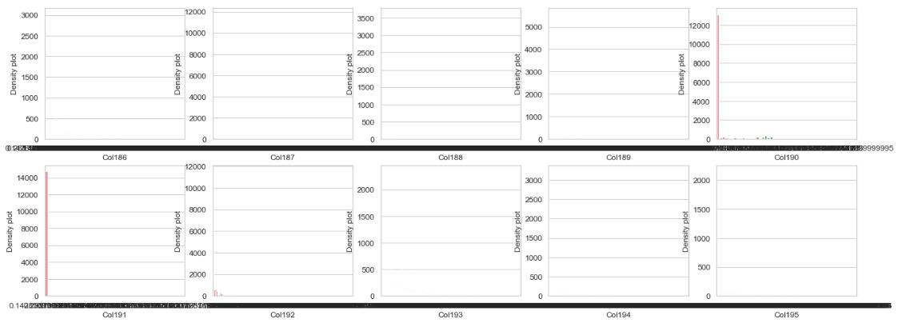

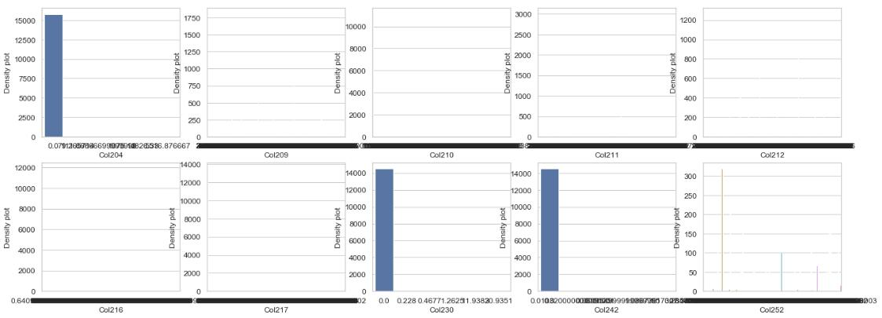

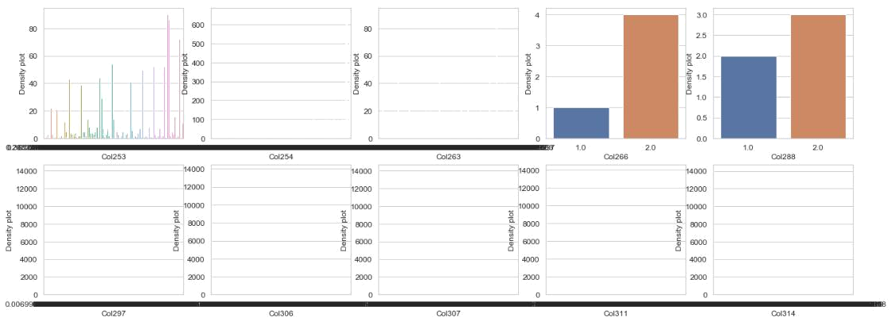

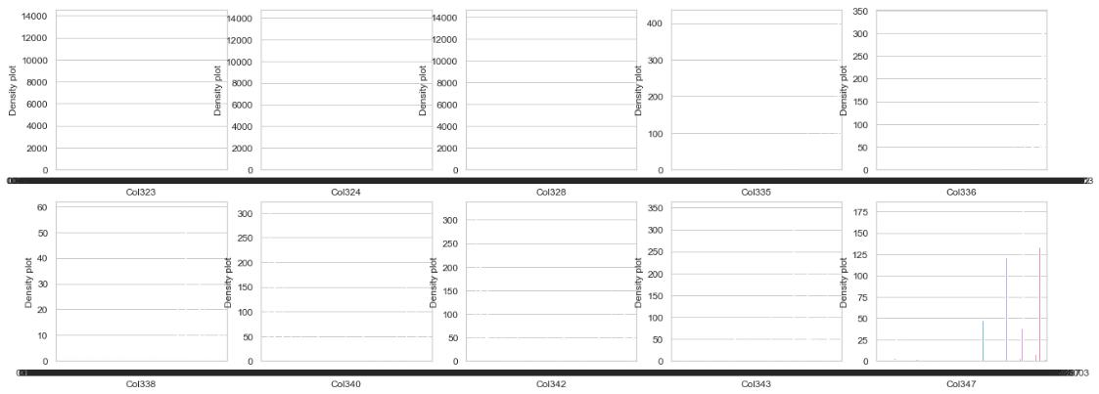

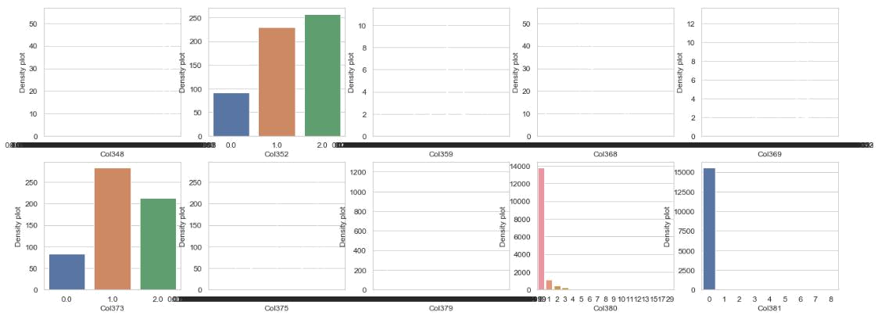

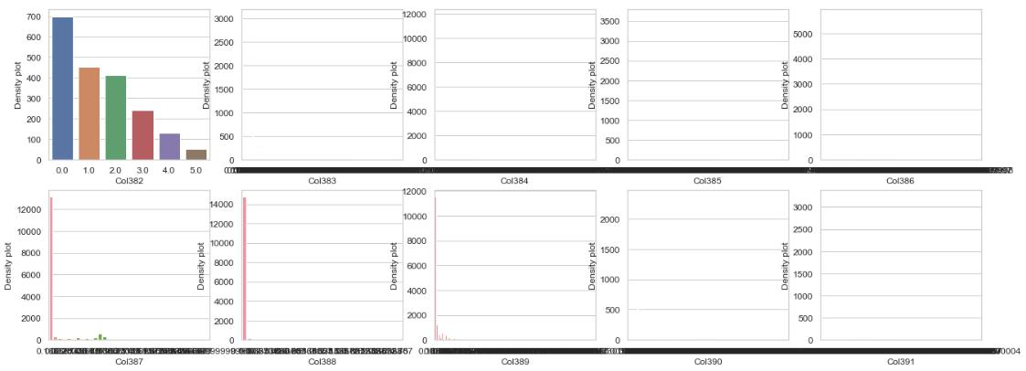

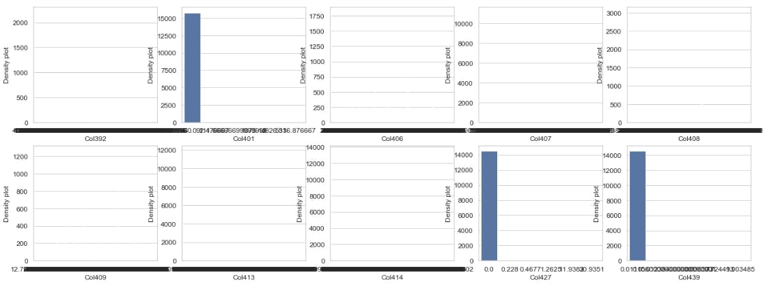

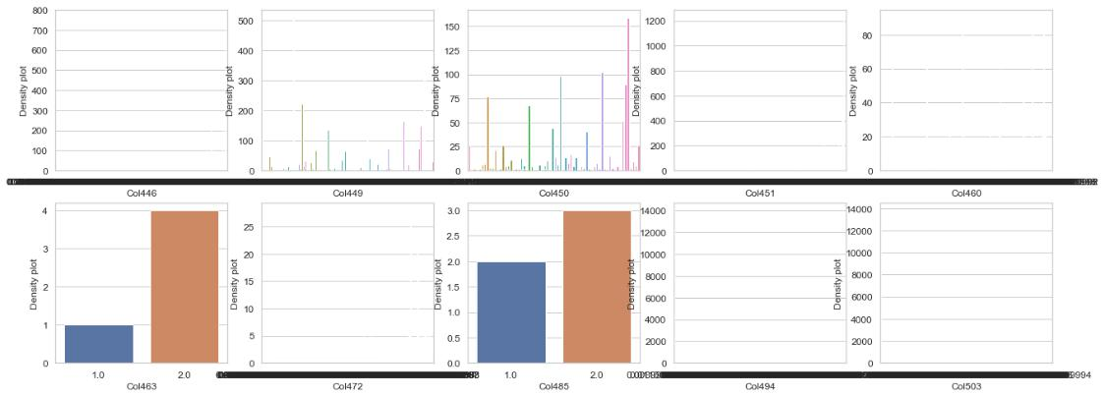

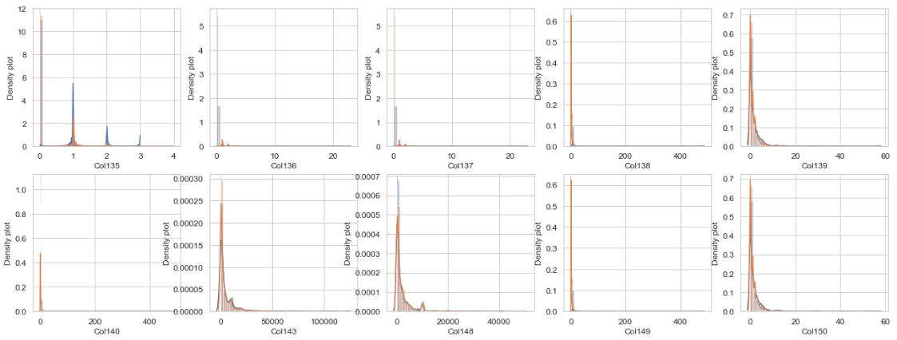

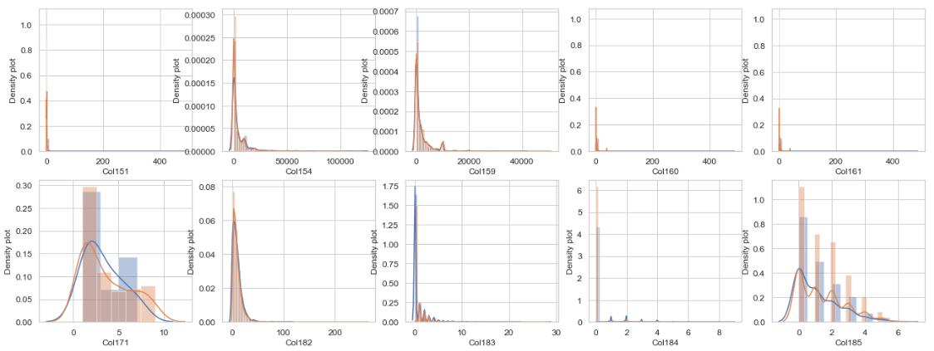

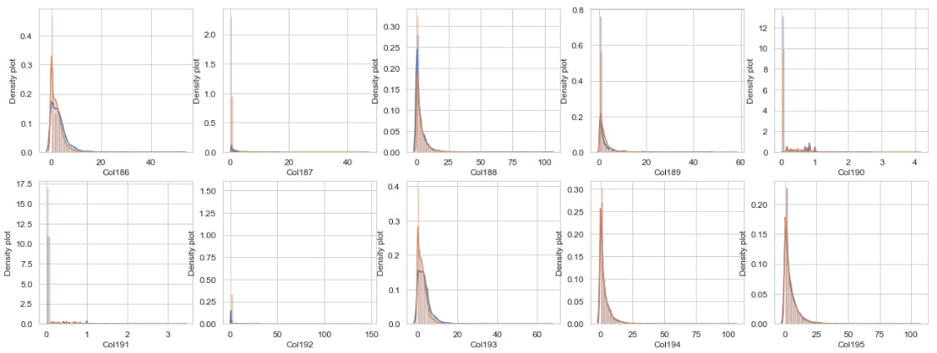

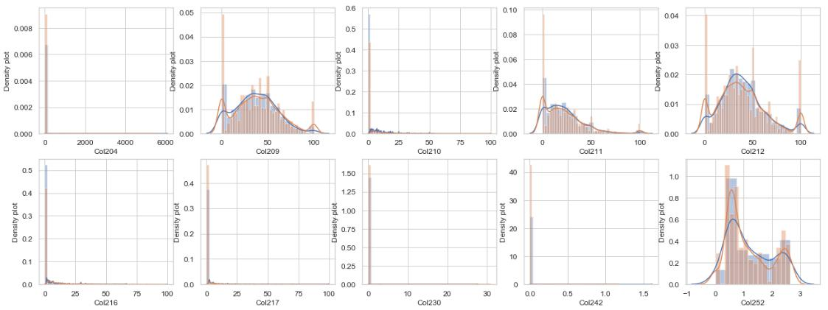

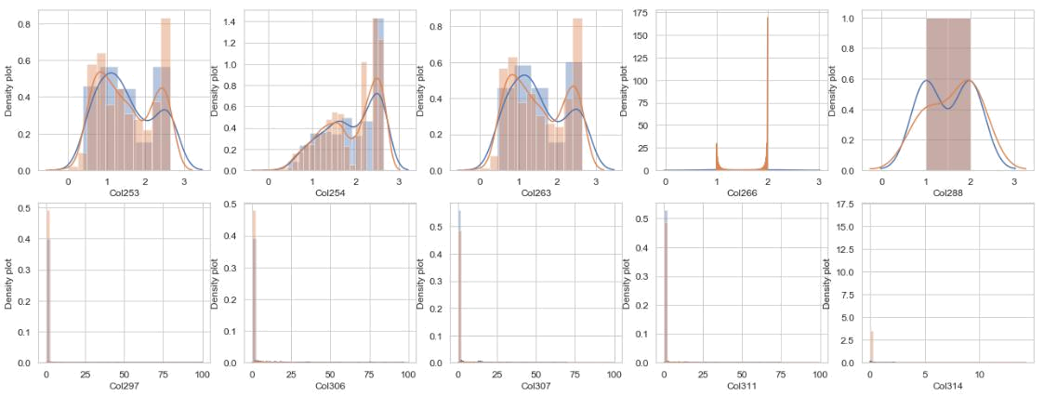

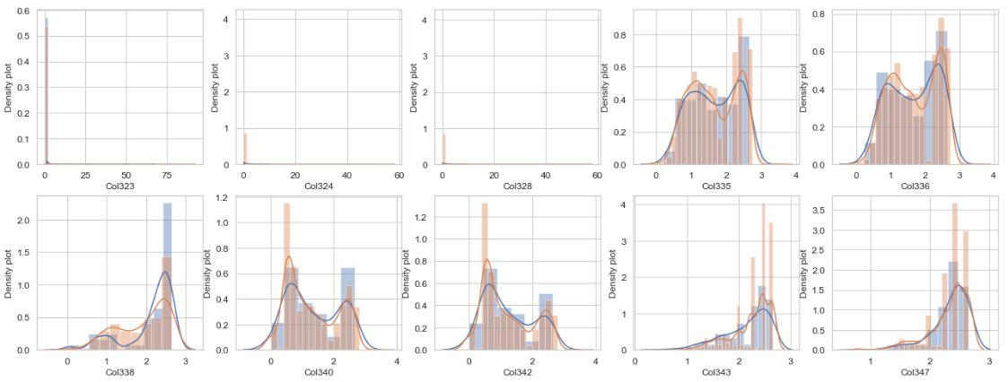

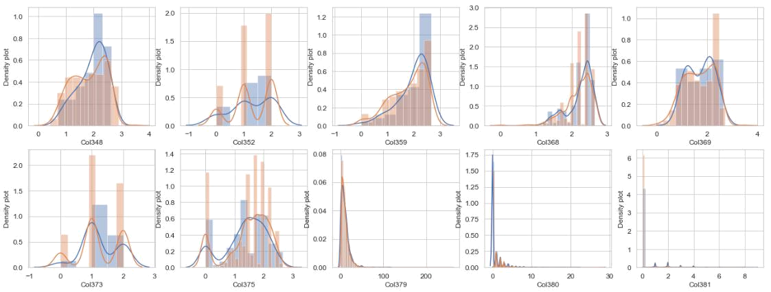

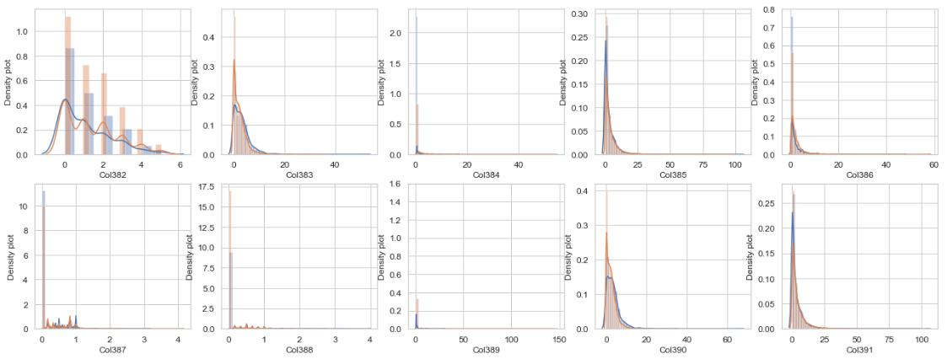

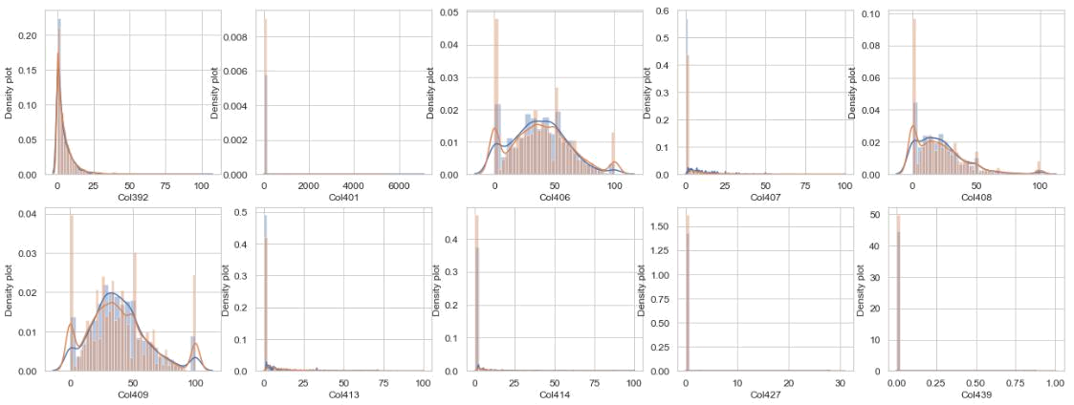

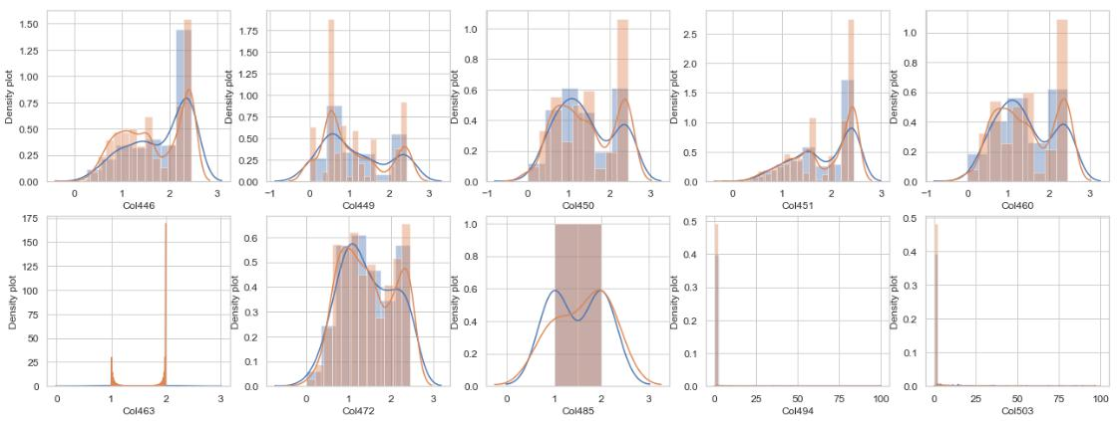

**3.2** **There is very high correlation among some feature**

* Following is some of interesting columns, which some-time helps in decision making **with** **very high impotance** and other time, it has **null importance**.
* i tried to analyze them differently

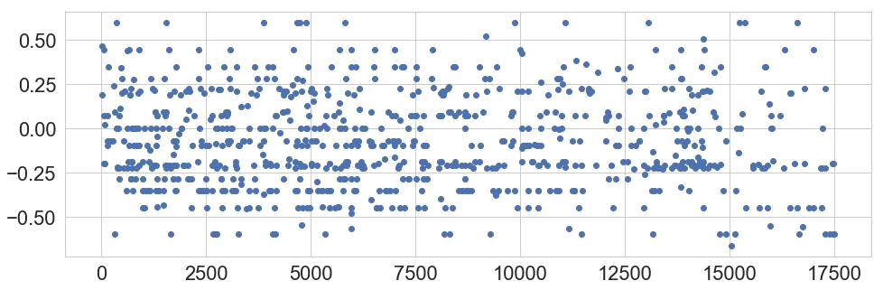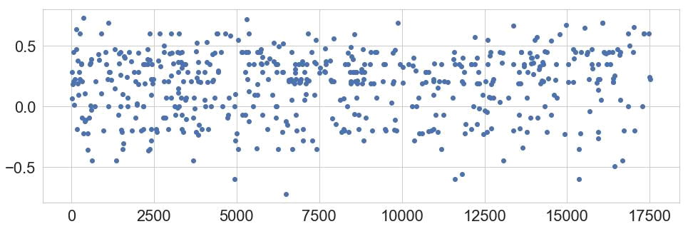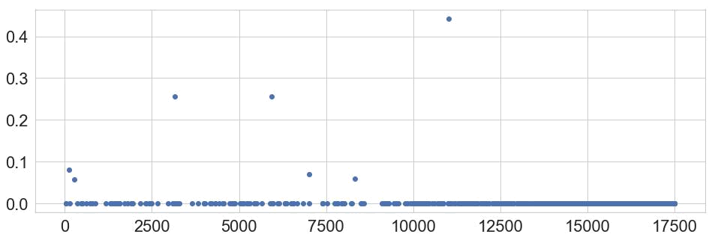

25

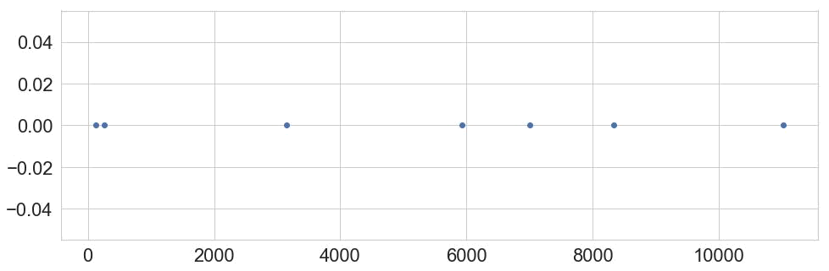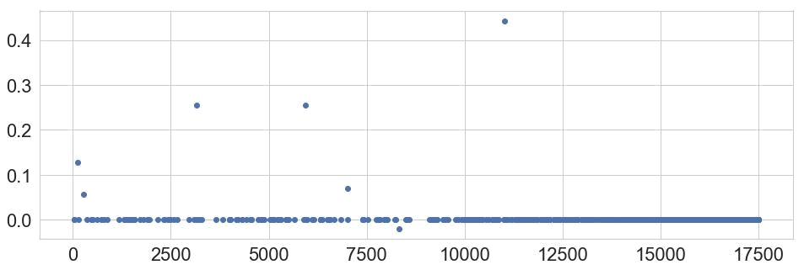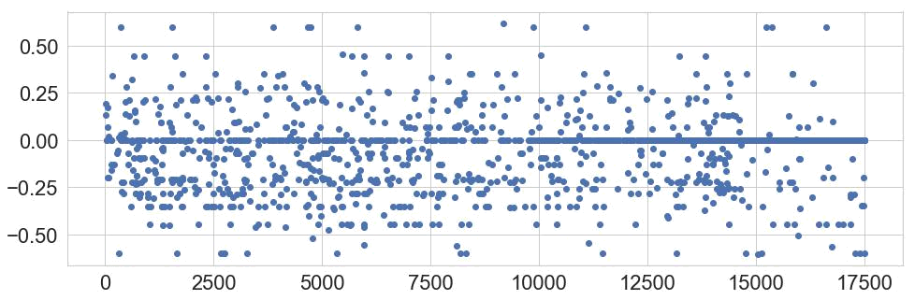

26

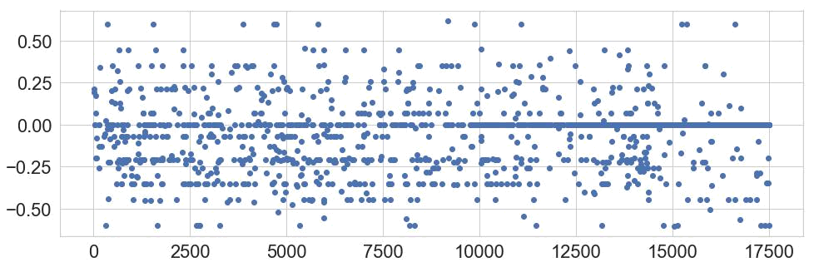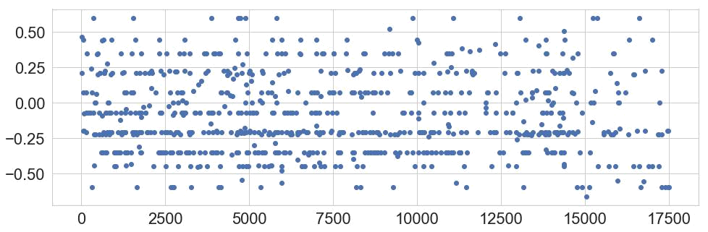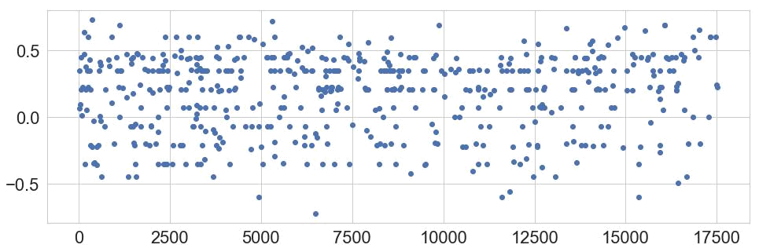

27